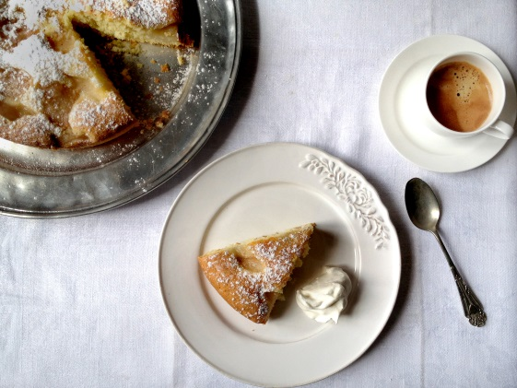
Simple Italian Pear Cake
This Italian pear cake is so elegant in its simplicity.

Ingredients
3 ‘very’ ripe pears – peeled & cut into chunks
1 & 1/4 cup plain flour, sifted
3/4 cup caster sugar
1 tbsp baking powder
1/4 cup corn flour (corn starch)
1 pinch salt
1/3 cup + 1 tbsp butter (slightly melted)
3 eggs
Powdered sugar (to sprinkle/ decorate on cake)
Whipped cream (optional, to serve)

Pre-heat the oven 350°.
Cream the eggs and sugar until light and fluffy. Sift the flour, corn flour, salt and baking powder together. Add the flour mix and stir well, add the butter till the batter is smooth.
Line a 9 inch cake pan with parchment paper, and pour in the batter.
Peel the skin off the pears, cut in chunks and drop them on the cake, gently pushing down each piece of pear. It doesn’t matter if the pear sticks out of the cake it will all blend in.
Bake for 30 minutes max. Leave to cool before serving.
When cool sprinkle icing sugar on cake. Serve with whipped cream on the side.

